**Rock Vs Mine Classifier**

**Python**

1. **Import file using panda read_excel**
2. **Slice the dataframe into two arrays X & Y**
3. **Map categorical target variable as binary**
4. **Check for outliers and replace with mean of that variable**
5. **Impute all missing data with mean**
6. **Split data into test and train using train_test_split from sklearn.model_selection**
7. **Use LogisticRegression from sklearn.linearmodel to model the relationship and predict the target variable**
8. **Append the predictions table to sonar dataframe**

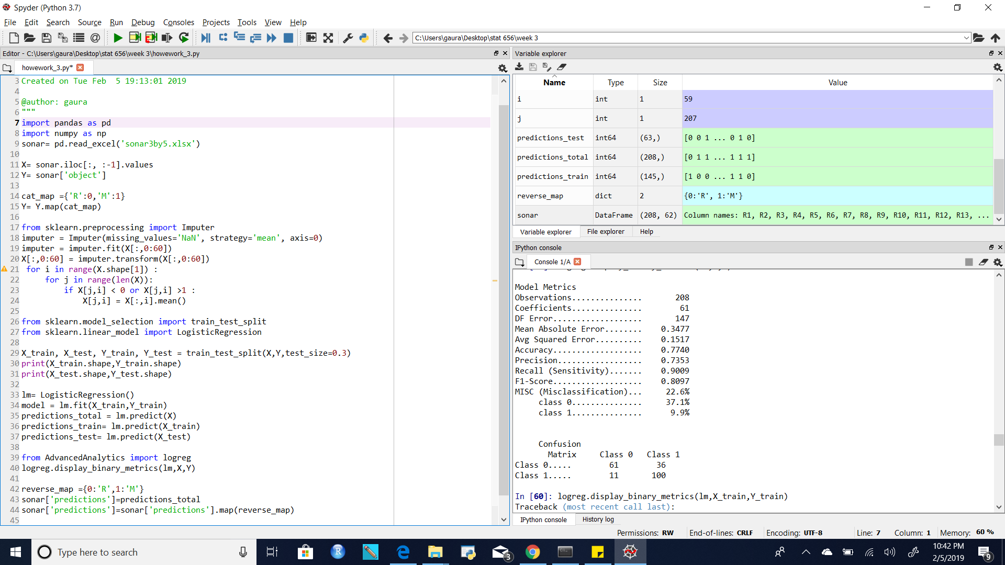

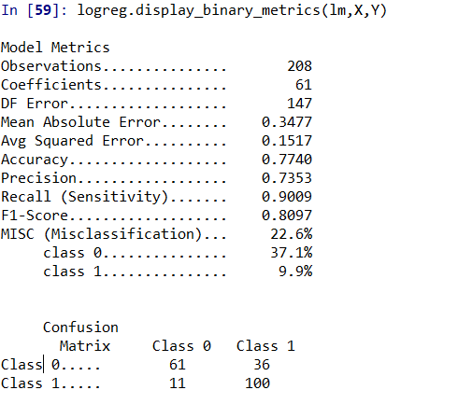

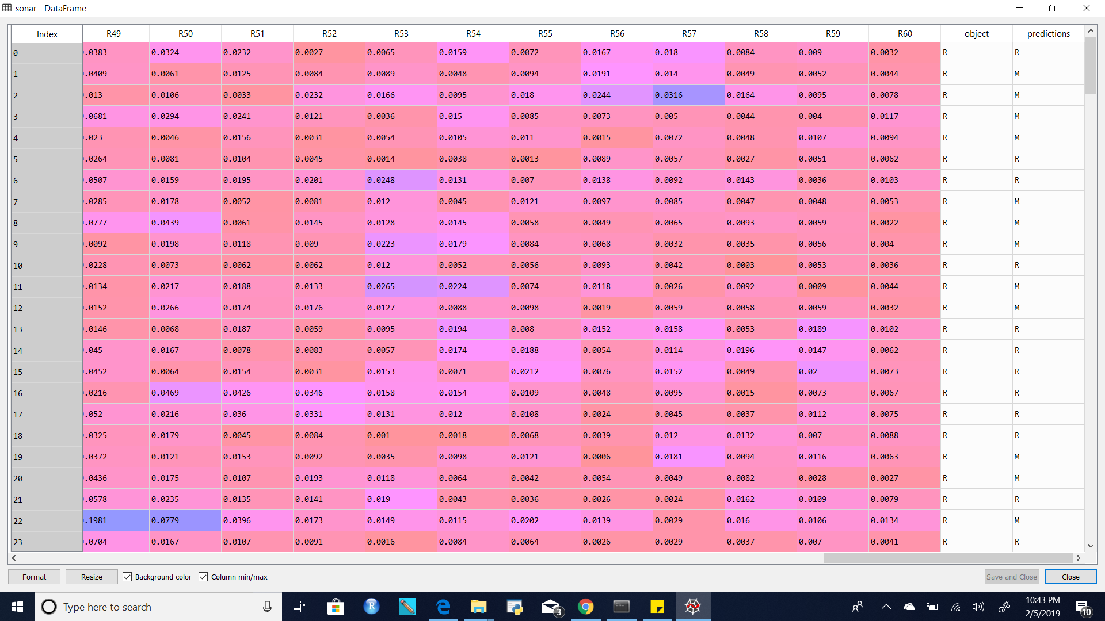

SAS

